****

**TECTG**



**BROADNET**

**Your Reliable Messaging HUB**

* System/Brand name: **BROADNET SMS Gateway**
* Date when first client went live: **August 2003**
* Current version and release date: **2018-V.3.4.5**
* Number of Clients using this software solution: **80,000 clients**
* Largest customer for this product (or service) by Number of users: We have more than 60,000 clients using our SMSC through different channels
* BroadNet is terminating more than **300M SMS per day** at the moment
* Integration offered is **Http/Https/XML/SMPP/SMPP over SSL**, optional **VPN**
* Our SMSC is fully compliance with **SMPP Standards**, few of our developers also contributed to the **protocol design itself.**
* Integration with any system usually is done same day, we do provide **support** **24/7/365** through calls, skype and emails.
* Any **issue is 98% solved same day** due to our strong business relations with local and international operators and carriers.

**Total Number of Employees:**

****

**Branches:  
LEBANON I UK I UAE I INDIA I ITALY I MALTA I EGYPT I KSA | Jordan | Australia | USA| Bahrain | Oman | Singapore | Nigeria | Turkey**

***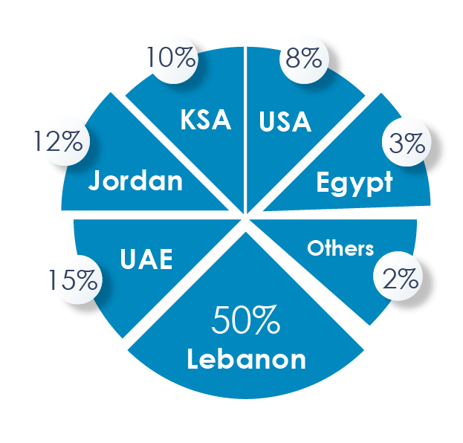*Total Number of clients:**

*We have more than* **80,000 Clients** *using our SMSC*

* **General Organization Capability:**

|  |  |  |  |
| --- | --- | --- | --- |
| **Client** | **Contact Name** | **Number** | **Type of Module/version used** |
|  |  |  |  |
|  |  |  |  |
|  |  |  |  |
|  |  |  |  |
|  |  |  |  |

****

**BROADNET PLATFORM**

1. We support **Multilingual messaging solution** supporting **10 Languages** at the moment.
2. **Generating detailed report** in Excel/PDF/txt

The report contains:

The mobile-wise, Date-wise, Product-wise, category-wise reports, transaction based reports, the short code wise, aggregated reports per category. Time stamps of SMS

sent to telecom operator, actual delivery to the end user and final status of SMS alert

along with status description.

1. We **maintain data** with regards to SMSs sent for 5 years our side as per Lebanese Law. For Europe Clients we follow GDPR with 1-year retention.

The data maintained could have the following fields: Mobile number/ MSISDN complete Message text Message Category Bearer (GSM/CDMA) operator circle National/ International sender Name/ ID date/ time of SMS received at the gateway Date/ time of SMS sent to the operator Date/ time of SMS delivered to the end

subscriber Final status to the SMS Status.

1. We offer answapicon_1.png **Online ticketing mechanism** for logging and tracking all the complaints raised by the clients and partners
2. The messaging platform supports **reliability and timeliness**, **secured and trusted** environments, single entry point and uniform application access.
3. The **messaging platform** is able to send and process various categories of SMS services like **personalized messages, Broadcast, Scheduled, Events, Emojis, Attachments** (Files, Music, Pictures, Videos…). Users can create different type of groups, add/remove and edit on the fly. Message customization can be a mix of any languages (Arabic, English…)
4. The messaging platform **supports the transmission of SMS messages** incorporating any required data encoding, splitting and concatenation, prioritizing and scheduling.
5. Bulk SMS will **support comprehensive range of application interfaces** like SMPP interface, (S) FTP interface, Web/Simple interface, upload interface, Group Message Interface, http Interface
6. Bulk SMS supports both **instant mode and scheduled mode.**
7. The message platform **supports Sender id mask.** (Sender ID may be a defined alpha- numeric string, which is visible on the phone as send id)
8. **SMS** services is the **core business** of BROADNET

We are able to:

* send, deliver & report standard SMS generated by system (automated)
* send, deliver & report standard SMS bulk Marketing campaigns
* send, deliver & report standard SMS ad hoc campaigns
* ability to generate send and track SMSs from your end
* able to register any sender ID at worldwide operators according to the policies and rules in each country. (In some countries we need documents) for Lebanon it’s ready to be used.

1. The expected **SMS delivery time**, and SMS maximum delay time:

* High priority/Alerts: less than 3 sec
* Transactional: less than 5 sec
* Promotional SMSs: less than 1 min



1. **local** high **speed** coverage: **600 SMS/Second**
2. **International** high-speed coverage directly through operators: **999 SMS/Second**



1. We have **point to point relation with local operators**
2. ability to check the **remaining SMS credits** at any time
3. ability to create and use **multiple Sender IDs**
4. proactive **alert system** (traffic monitoring to report abnormal behaviors)



1. Offering **HLR system** (to filter wrong formats)



1. ability to **manage** our own **threshold/ parameters**



1. Multilevel Platform to support **Admins/resellers/childs accounts** with **credits/reporting/sending/routing.**
2. **24/ 7 Technical Support** will immediately solve at hand troubles, running tests and

direct communication with your company.

1. The **API parameters support** encryption decryption and also supporting the **3DES/AES algorithm.**
2. **Scheduling mechanism** is available through **online and API** as well.



1. The capability to **integrate** the SMS solution **with new applications, middleware/Enterprises Application Interface (EAI).**



1. The ability to **securely store sensitive data.**



1. We have **business continuity plan.**

**Moreover, we have Advanced Messaging System (AMS)**

* Advanced User management (Create-Modify-read) rules, Show/Hide connection parameters, & permissions
* encrypted database and secure communication
* Easy to install and integrate
* Secure & reliable system with backup & redundancy built in
* Multi Licensing Keys based on purchased module
* Backup/restore System Features
* Internal Contacts /Groups address book with full management module
* Two-way SMS
* SMS formats, supports a wide range of SMS formats including 7bit ASCII, 8bit binary, User Data Header SMS

(UDH - for operator logos, picture messages, ringing tones, WAP OTA settings, vCAL entries, WAP bookmarks, etc.) and Unicode SMS

* Delivery Reports, Tracking of SMS and long SMS messages
* Support GSM hardware USB dongles for incoming SMS’s through local sim
* Support Web listener for incoming sms’s through vendor API
* Standalone Web Server/Secured web services (HTTP, HTTPS, SOAP, XML, JSON)
* Multi sender ID creation
* Support multi Database read Write integration (Oracle.MSSql, MySQL, Sql lite, MS Access, Excel,
* ODBC-MySQL, , ODBC-MySQL, ODBC- ODBC-Sql lite, ODBC-MS Access, ODBC-Excel)
* Easy to install, System auto create, update database tables
* Monitoring service check (standalone application) to monitor
* Real-time Pending, Queue, History records and statistics
* Logger module, (NB: AMD Don’t Log Sensitive Data)
* Advanced connection grouping
* Advanced routing based on sender, content...
* Message Trigger Builder
* Message content, Sender ID, Connection Group, Destination numbers, Task Schedule,
* conditional time sending, Message restriction and rules control
* Detailed Reporting with charts for incoming and outgoing Traffic with charts and export services